## Add Product

### Request body

{

    "Name": "LED Candle",

    "Image": "/assets/candle.jpg",

    "Description": "In darkness see, combustion-free. Batteries not included.",

    "Cost": 5.5,

    "ShippingCost": 1.25

}

### Test script

pm.test("Response matches success message", function () {

    pm.expect(pm.response.text()).to.include("LED Candle has been saved in the database.");

});

### Test output

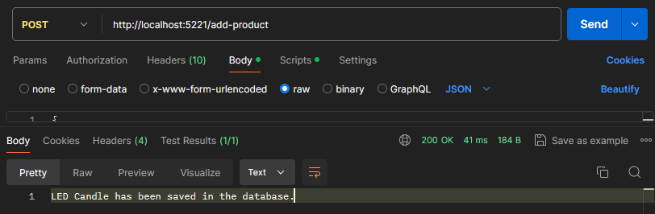

## Update Product

### Request body

{

"Id": "2",

    "Name": "LED Candle",

    "Image": "/assets/candle.jpg",

    "Description": "In darkness see, combustion-free. Batteries not included.",

    "Cost": 11,

    "ShippingCost": 1.25

}

### Test script

pm.test("Response matches success message", function () {

    pm.expect(pm.response.text()).to.include("Updated LED Candle.");

});

### Test output

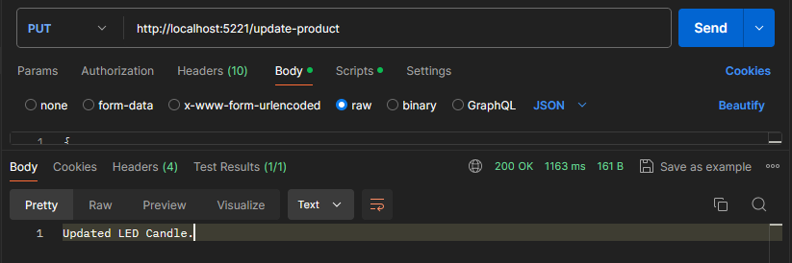

## Get Products

### Request body

None

### Test script

pm.test("Response yields all products", function () {

    pm.expect(pm.response.json().length).to.equal(2);

});

### Test output

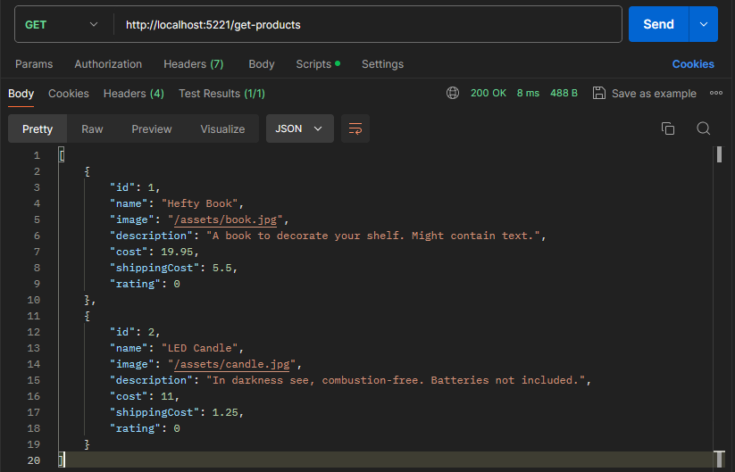

## Register

### Request body

{

    "Name": "Daniil",

    "Email": "dpaskal0409@conestogac.on.ca",

    "Password": "password",

    "Address": "1 Sample Street",

    "Province": "Ontario",

"PurchaseHistory": []

}

### Test script

pm.test("Response matches success message", function () {

    pm.expect(pm.response.text()).to.include("Daniil has been saved in the database.");

});

### Test output

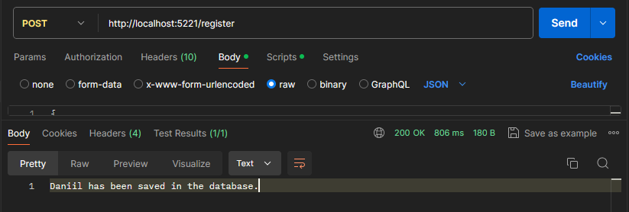

## Get Users

### Request body

None

### Test script

pm.test("Response yields all products", function () {

    pm.expect(pm.response.json().length).to.equal(1);

});

### Test output

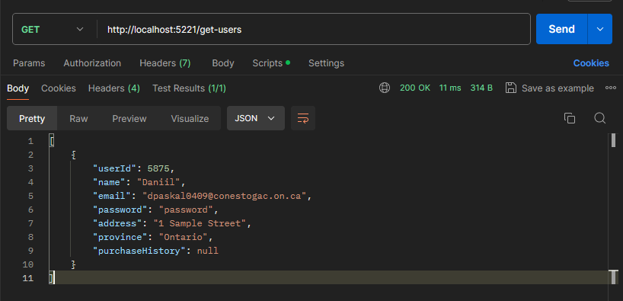

## Update User

### Request body

{

    "UserId": 5875,

"Name": "Daniil",

    "Email": "dpaskal0409@conestogac.on.ca",

    "Password": "password",

    "Address": "100 Example Street",

    "Province": "Ontario",

"PurchaseHistory": []

}

### Test script

pm.test("Response matches success message", function () {

    pm.expect(pm.response.text()).to.include("Updated Daniil.");

});

### Test output

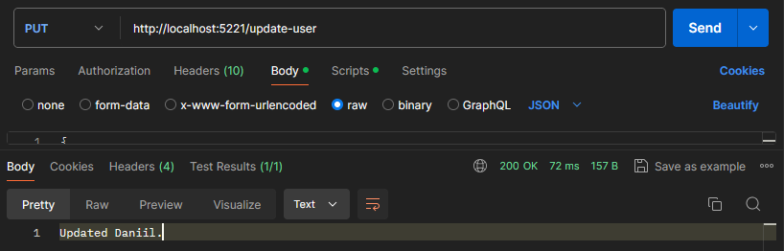

## Login

### Request body

None

### Test script

pm.test("Response matches success message", function () {

    pm.expect(pm.response.text()).to.include("User authenticated.");

});

### Test output

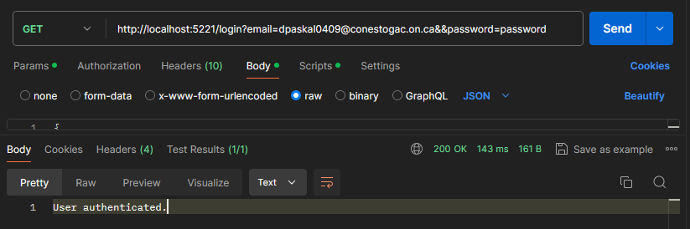

## Add Comment

### Request body

{

    "productId": "1",

    "userId": "5875",

    "rating": 4,

    "text": "Could be heftier.",

    "images": []

}

### Test script

pm.test("Response matches success message", function () {

    pm.expect(pm.response.text()).to.include("Comment saved in the database.");

});

### Test output

## Get Comments

### Request body

{

    "id": "1",

    "name": "Hefty Book",

    "image": "/assets/book.jpg",

    "description": "A book to decorate your shelf. Might contain text.",

    "cost": 19.95,

    "shippingCost": 5.5,

    "rating": 0

}

### Test script

pm.test("Response yields all comments for product", function () {

    pm.expect(pm.response.json().length).to.equal(1);

});

### Test output

## Update Rating

### Request body

{

    "id": "1",

    "name": "Hefty Book",

    "image": "/assets/book.jpg",

    "description": "A book to decorate your shelf. Might contain text.",

    "cost": 19.95,

    "shippingCost": 5.5,

    "rating": 0

}

### Test script

pm.test("Response matches success message", function () {

    pm.expect(pm.response.text()).to.include("Rating has been updated to 4.");

});

### Test output

## Update Cart

### Request body

### Test script

pm.test("Response matches success message", function () {

    pm.expect(pm.response.text()).to.include("Updated cart.");

});

### Test output

## Get Cart

### Request body

{

    "UserId": 5875,

"Name": "Daniil",

    "Email": "dpaskal0409@conestogac.on.ca",

    "Password": "password",

    "Address": "100 Example Street",

    "Province": "Ontario",

"PurchaseHistory": []

}

### Test script

pm.test("Response yields cart", function () {

    pm.expect(pm.response.json()).to.be.an('object');

});

### Test output

## Record Order

### Request body

{

    "UserId": 5875,

"Name": "Daniil",

    "Email": "dpaskal0409@conestogac.on.ca",

    "Password": "password",

    "Address": "100 Example Street",

    "Province": "Ontario",

"PurchaseHistory": []

}

### Test script

pm.test("Response matches success message", function () {

    pm.expect(pm.response.text()).to.include("Recorded order.");

});

### Test output

## Delete User

### Request body

{

    "UserId": 5875,

"Name": "Daniil",

    "Email": "dpaskal0409@conestogac.on.ca",

    "Password": "password",

    "Address": "100 Example Street",

    "Province": "Ontario",

"PurchaseHistory": []

}

### Test script

pm.test("Response matches success message", function () {

    pm.expect(pm.response.text()).to.include("Deleted user with email dpaskal0409@conestogac.on.ca.");

});

### Test output

## Delete Product

### Request body

{

    "id": "2",

    "name": "LED Candle",

    "image": "/assets/candle.jpg",

    "description": "In darkness see, combustion free. Batteries not included.",

    "cost": 11,

    "shippingCost": 1.25,

    "rating": 0

}

### Test script

pm.test("Response matches success message", function () {

    pm.expect(pm.response.text()).to.include("Deleted product named LED Candle.");

});

### Test output

### 